Chapter 10, Problem 6.

Determine V_{x} shown in Fig. 10.55

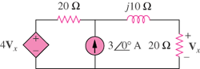

Figure 10.55
For Prob. 10.6.

